**Creating Database in PostgreSQL:**

**Creating Database:**

**Drop Database:**

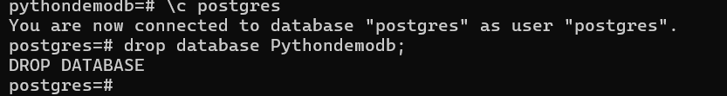

**Create Table and Add Data:**

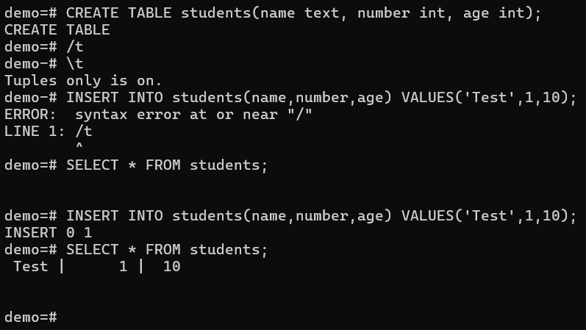

**DELETE DATA:**

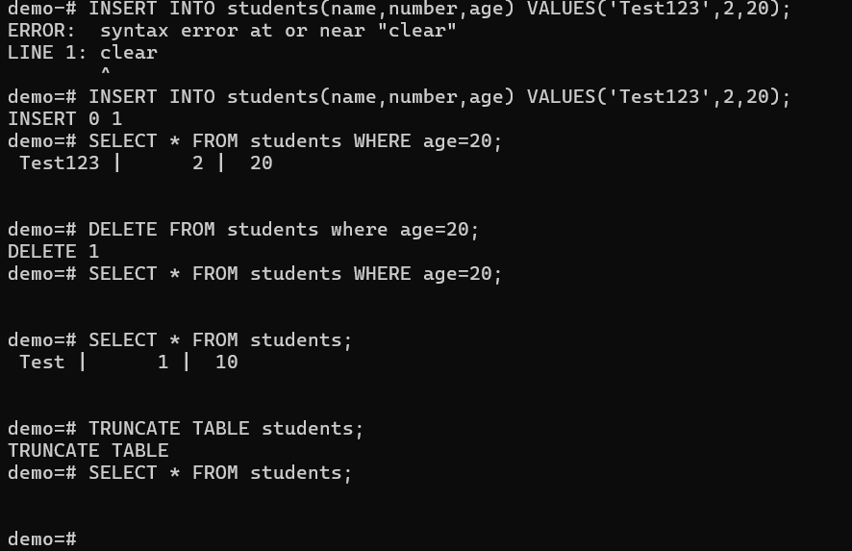

**Running Python script on Virtual Environment:**

**Activate and Deactivate Virtual Environment:**

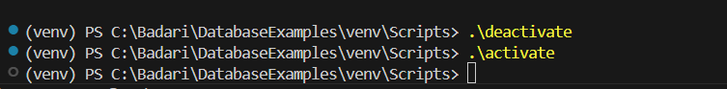

**Connecting Postgres in Python using VSCode Terminal:**

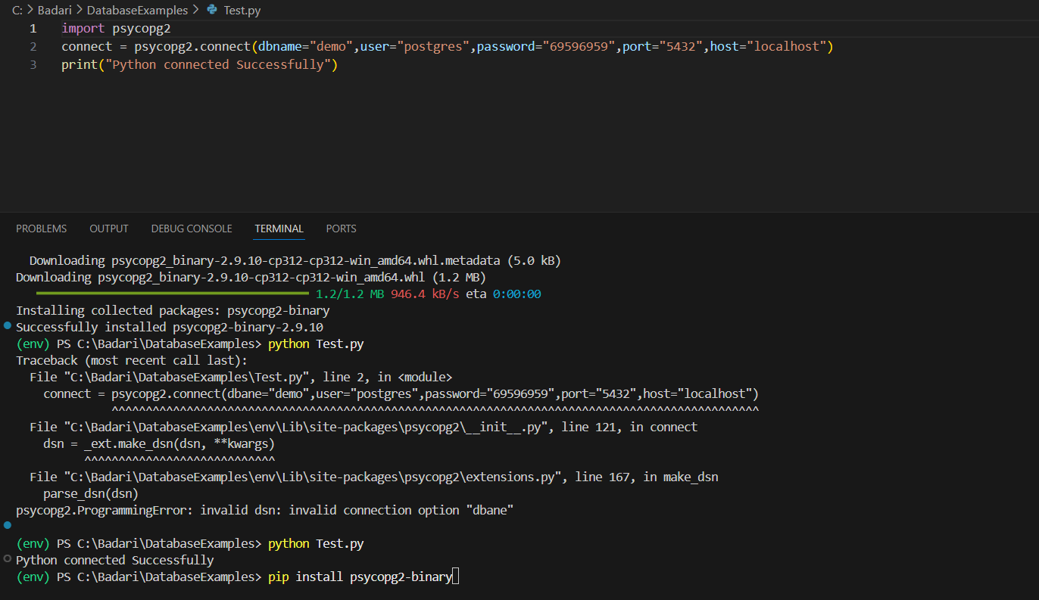

**Table Creation:**

**Data Insertion:**

**Get Data:**

**Insert Data with Input parameters:**

